niras**MINISTRY OF AGRICULTURE AND RURAL DEVELOPMENT (MARD)**

**VIETNAM ADMINISTRATION OF FORESTRY (VNFOREST)**

**FORMIS II**

**Development of Management Information System for Forestry Sector in Vietnam**

Supported by: Government of Finland

Date March 22nd 2017

FORMIS Training process, Training management and FRMS Support (Draft/Proposal)

Name: Mikko Nivala

Ismo Sarajärvi

Position: Associate Technical Adviser, FORMIS II

International Training and Communication Adviser, FORMIS II

FORMIS II

Development of Management Information System for Forestry Sector in Vietnam

# **Table of Contents**

1 Background 3

2 FORMIS training processES 4

3 Definitions of FORMIS training processes 5

Training need assessment 5

Training organization and leadership 7

Training material management 8

Trainers management 9

E-learning system management 10

HelpDesk and application support 11

4 Training management in central level 11

5 Training management in Regional level 11

6 Training management in province, district and commune level 12

7 FRMS training management 12

8 Conclusion and Proposal 14

References 15

# Background

Development of Management Information System for the Forestry Sector in Viet Nam – Phase II (FORMIS II) is implemented by the Vietnam Administration of Forestry (VNFOREST) under the Ministry of Agriculture and Rural Development (MARD). The purpose of FORMIS II is to develop a fully integrated Management Information System (MIS) for sustainable management of forest resources and in this way contribute to the alleviation of poverty in the socio-economic development of Vietnam.

FORMIS II key targets are to develop a modern information system to manage forest resource data, to create information standards and information sharing mechanisms for forestry sector, to create capacity for forest related information management and to set up a Forest IT unit within VNFOREST.

In order to strengthen capacity building for VNFOREST and FPD as well as to the related stakeholders in forestry sector, FORMIS project has run intensive training including central, regional and provincial TOT training and district level user training. There has been no clear documentation of FORMIS training process, training management and application supporting. The purpose of this document is to support the hand-over of the training responsibility to VNFOREST, FPD and other stakeholders. The document highlighting the key processes included to the training process and training management.

The training process and training management has been divided in this document to three different administrative level due to de-centralized management in governmental organisations in Viet Nam. The FRMS support has own chapter as it is one of the key applications of FORMIS project and to maintain the forest resource database up-to-date.

# FORMIS training processES

This first chapter is clarifying the key processes that are included to the FORMIS training. Each training process is explained more detailed in the next chapter. There are also chapters that explains FORMIS training processes in each administrative level to clarify the training management differences from central to local level.

FORMIS Training including following processes:

* Training need assessment (in each administrative level)
  + User policy (amount of needed users among different stakeholder groups)
  + Needed capacity and skills to maintain FORMIS and to use the FORMIS applications
  + Capacity incensement strategy: Training, recruiting, outsourcing (budget and planning)
  + Curriculums based on the needed skills
* Training organization and leadership
  + Official mandate to provide training
  + Training preparations (preparing agenda, preparing schedule and venue, invitations to trainees and trainers, permissions, material preparations,..)
  + Organization skills to run training course (moderating skills, timing, leadership and general training management skills)
  + Training feedback collection and reporting (training quality improvement and result-based management)
* Training material management
  + Guidelines
  + Exercises
  + Lectures / PowerPoints / Webinars
  + Video materials
  + Courses
  + Curriculums
  + Training material quality management
  + Training material improvement and development
* Trainers management
  + Training of Trainers
  + Trainer’s skills management (sufficient amount of capable trainers for each application and processes)
  + Trainer’s evaluation
  + Trainers skills’ improvement management and planning
* E-learning system management
  + Overall curriculum (linked with Training material management)
  + Course management (linked with Training material management)
  + Material management (linked with Training material management)
  + Competence reports
  + HelpDesk and Support
  + Administrative tasks (User accounts, Course creation, Appearance, Maintenance in Server)
* HelpDesk and application support
  + HelpDesk system for each application (Moodle alone is not a enough as face-to-face support is still needed)
  + Monitoring and development of the support process of the HelpDesk and application support

This above mentioned training management processes have been defined and distinct from each other in a way that each process could be organized and managed separately or even handed-over to different organisations. The detailed description and needed competence to take over the responsibility is described in the next chapter.

# Definitions of FORMIS training processes

## Training need assessment

The training need assessment is one the most important process as it provides results for the activities in other processes. Training need assessment means the activities to understand the needed capacity to do the tasks, collect the information of the current capacity and planning the activities to tackle the capacity gap between the need and current situation. The training need assessment also prevent the capacity gap in future because of job rotation or changing environment.

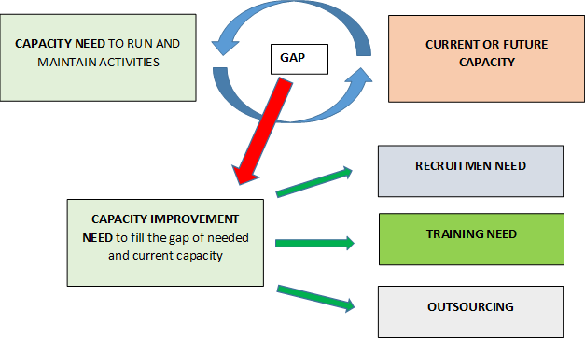

It is good to understand that sometimes the training might not be the only solution for the needed capacity as it is possible to recruit or outsource/buy the service to fulfill the need.

Training need assessment start with the analysis what competence is needed to run and maintain the activities. It means that each job profiles need to be defined in order to run the activities. After that, each profile need to be analyzed to understand the skills and capacity that is needed for that position.

For example, if district have 10 000 ha and according to the interview of the rangers, it is needed to have 2 persons to keep the database updated using FRMS (for all the communes) and 10 people to collect and monitor the changes in forest by field measurements (providing data for updating), then there will be two job profiles: one for using the FRMS to keep the database update (Data entry) and one for collecting or gathering the information of the changes from different sources or using different methods (Data provider / Data collector). The first profile would need higher competence in GIS and IT skills and the second profile more higher competence in field inventory skills such as use of GPS devices. For each job roles, it is needed to define what kind of tasks they need to run and then define the skill that is needed for those tasks. Also, it is important to analyse the situation how many persons are needed for each job profile. Finally, it is needed to survey, what is the current competence or what will be the future situation of the competence. The competence can be changed, for example because of the job rotation. It is needed to plan the actions or training to make sure there will be capacity to run the activities now and in future.

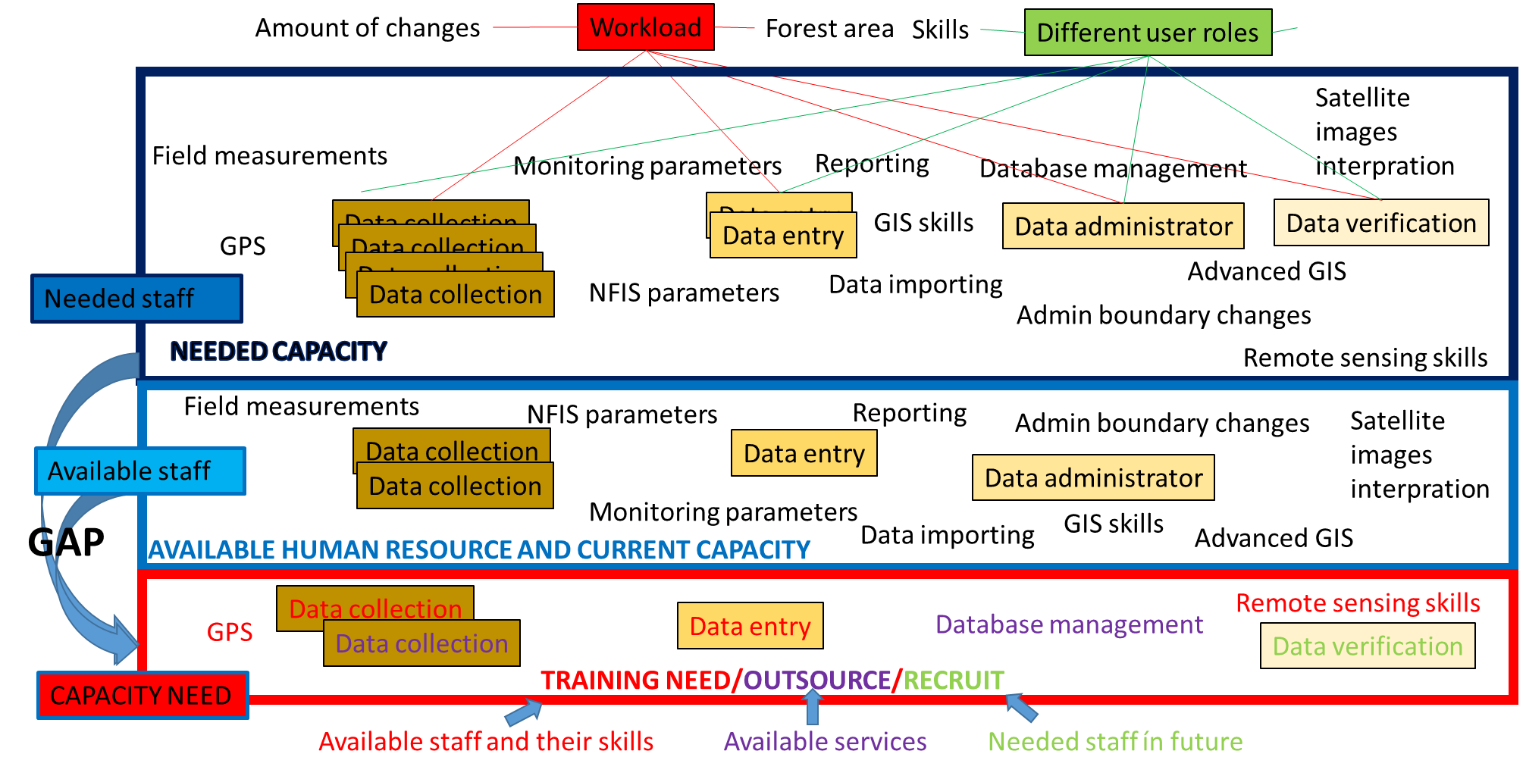

The training need assessment should be done annually but the information can be collected throughout the whole year.

The training need assessment should be done or at least supervised by the organization that is the main user of the application or the system. The data collection process and analysis could be outsourced for the service provider but the main decision making of the training need should not be outsourced outside the main organization. The training need assessment needs a high understanding of the application/system and the processes involved. In method point of view, the training need assessment can be a simple survey (e-survey) for selected communes, each district and each province. The results can be aggregated to make district, province, regional and nationwide assessment and budgeting.

In case of FRMS, we would recommend to keep the supervision and decision making of the training need inside the VNFOREST and FPD organizations.

## Training organization and leadership

During the FORMIS II –project time, the training organization and leadership has been done by using FORMIS PMU resources. Training organisations and leadership means the strategical and operational training planning, scheduling, logistical arrangements, feedback collection, reporting, training quality assessment and quality improvements.

The organization that takes this responsibility needs to have official mandate for doing this task to make the work possible. The training management and leadership needs a lot of time and good networking skills to communicate with different stakeholders.

Training preparations means everything from agenda preparations to the activities until end of the training event and reporting. In order to prepare the training agenda, the organization needs to understand the training need, available resources (material, trainers), permissions (for trainers, trainees, data usage etc.) and scheduling. In the training planning, the budgeting and results based management is also important skills to have or understand.

When running the training course, the organization should be able to moderate the training event and be ready for possible changes. It is important to collect daily feedback for constant and continuously quality improvement. At the beginning of the training course, it would be important to register each participant (for example to the Moodle) and make a baseline survey to understand better the training need and current capacity but also to make it possible to analyse the results of the training. After the training, each participants should fill a feedback form that would help to improve the training material, trainers’ skills, scheduling, and venue or training methods. Also, each trainees’ skills need to be examined to report accurately the training results and to provide feedback for future training need as well as collect information how the training should be improved (trainers’ skill or highlighting different topics).

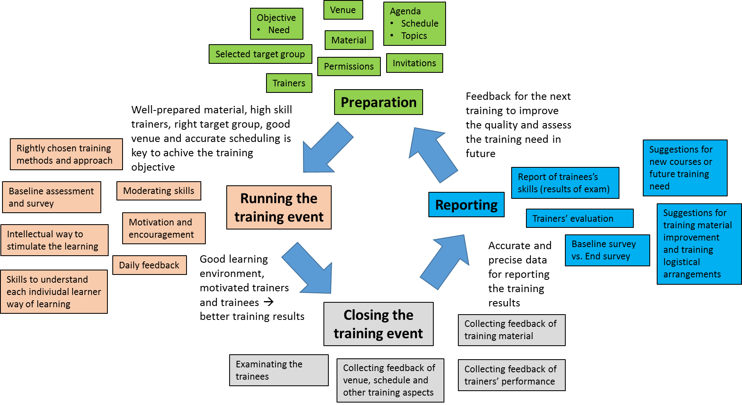

Naturally the training organization would be easy to hand-over for the organization that is specialized for the training such as universities. However, the organization should co-operate with VNFOREST and FPD.

## Training material management

Training material management should not be mixed with the creation of the new guidelines, exercises, videos, lectures and courses. Training material management is more like to collect the feedback of the training material for future development and improvement and make sure that the same and official/approved material is used by all training organisations. Training material management means more to keep on track what material is available and what material can be used or is accepted than the creation of the material itself. However, the material creation itself is one important part of the training material management but as mentioned above, it can be even outsourced.

There is a need to have a system where the official/approved material is stored and where it would be easier to access by different training organisations. The natural place for training material and courses to be stored and in use is the FORMIS e-learning system (<http://lms.vnforest.gov.vn/>). The organization that is responsible for the training material management, does not need to be necessary responsible of Moodle environment which is the platform where the FORMIS e-learnings system is built.

Currently FORMIS has following training courses in the training strategy:

* Basic QGIS and TOT training skills –course
* Advanced GIS TOT training
* Forest Resource Monitoring System
  + Desktop –application
  + Web –application
* Forest Resource Monitoring System TOT training
* Forest Resource Monitoring System Data verification training
* Forest Resource Monitoring System Data administrator training
* Forest Protection Department Quick Reporting System training
  + Desktop
  + Web and mobile –application
* Forest Resource Database training
* FORMIS e-learning system training
* Training skills training, Training of trainers
* English skills for DID and VNFOREST staff
* Database management training for DID
* Data and application integration process to DID
* ICT investment planning training for DID

As can be seen on the list of the training courses, the FORMIS training material and course management needs a lot of specialized skills in Forestry, GIS and Training.

The key skills for the training material management are: the understanding of the training topics, understanding the learner types and understanding the training feedback collection method and importance.

## Trainers management

Trainers’ management means the responsibility to maintain the sufficient amount of qualified and skillful trainers to run FORMIS training activities. As mentioned earlier, in a sustainable point of view, it would be important to have more than one organization to run FORMIS training. Trainers can be located and worked in different organizations but the management of trainers should be done centrally. There can be several organisations that are responsible of trainers training but the overall management should be coordinated centrally preferably by the owner of the application or process. Trainers’ capacity need to be assessed annually and there is a need of continuous training to make sure that the trainers know all the changes in policy, application and processes.

Trainers’ management needs skills to evaluate the trainers’ capacity in order to increase their competence and support the trainers to improve their weaknesses. Training of trainers is important part of the trainers’ management and capacity building but understanding the training need and training processes is playing also a significant role in Trainers’ management and capacity building.

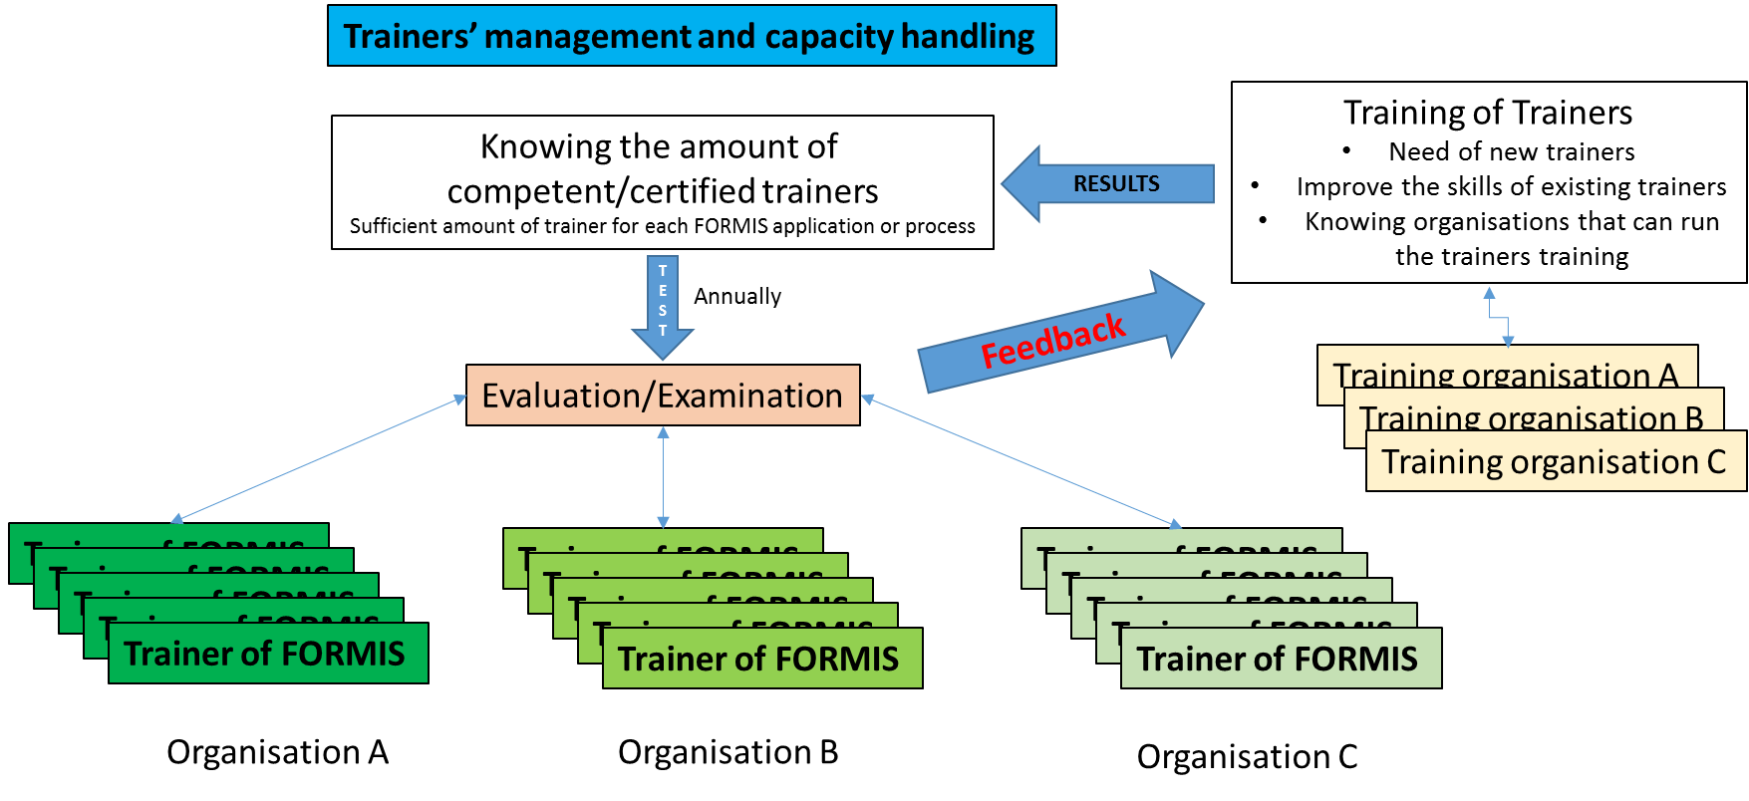

Our recommendation to the VNFOREST is to keep the Trainers’ management and capacity building inside VNFOREST and FPD regarding to the FRMS. They should be able to monitor that there are sufficient amount of trainers in different organisations. However, the training of trainers could be organized by different institutions and universities. The results of the training of trainers will automatically provide information what is the amount of competent trainers. The examination or evaluation of the competent trainers could be done by using e-learning system or as a results of training of trainers –service and the course reports.

## E-learning system management

The FORMIS e-learning system is a store of FORMIS training material and database of learners/users and teachers of the FORMIS system, including information of their skills and courses they have passed. FORMIS e-learning system is built on Moodle platform and it includes curriculums, courses and lectures of FORMIS related training. It can be used to test the skill of users and teachers, forum for discussion, communication channel, HelpDesk and application support.

The users of E-learning system can be categorized as: Student, Non-Editing teacher, Teacher, Course Creator and Administrator. This process what we mean here, is the administrative process of the e-learning system which includes some small parts of course creation and teacher skills of the Moodle. The administrative skill of e-learning system means everything from installation to the server to the maintenance, appearance and development of the e-learning system based on the user feedback. Administrator can also support in user account policy when new user profiles will be defined (now Guest, Student, Teacher, University, Evaluator and Admin –access). The user profiles should not be mixed with user roles. User profile make a basic setting for each user roles which can be changed between the courses. For example, one person can be a teacher in another course but student in another, more advanced course.

The user account creation can be done by any user by self-registration or by help of admin. The course creator or administrative persons are needed to enroll/assign the users to right role for the course. The logic of FORMIS e-learning system account policy is following (including the main tasks):

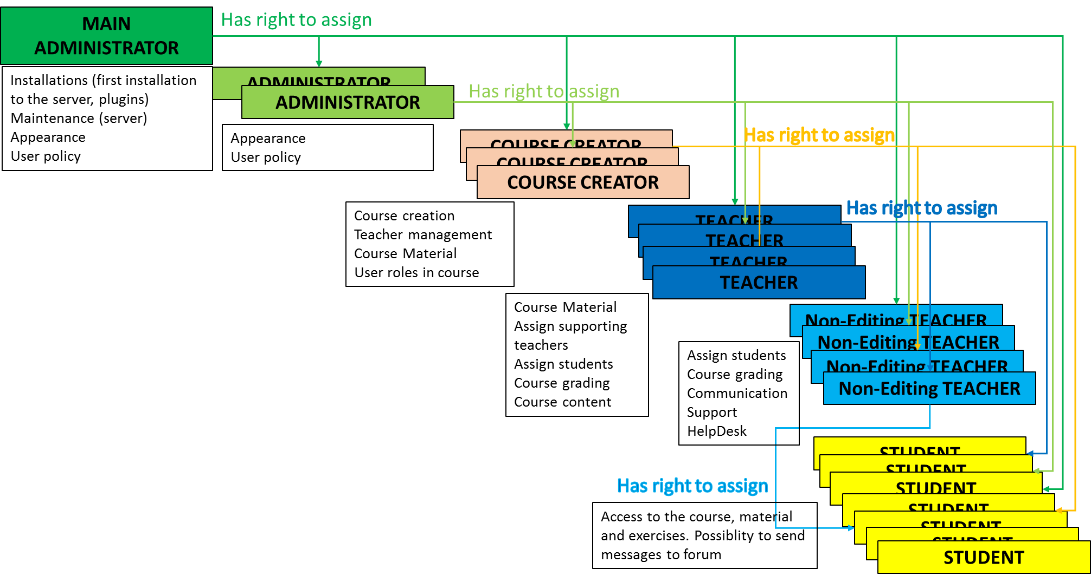

The main administrator and administrator can change the role to be in any category below to check and test the system functionalities. This means that the main administrator needs to understand well the functionalities of Moodle but also the training needs and process of FORMIS.

The maintenance of E-learning system needs understanding of Moodle platform and .php –programming. The organization should be able to work close co-operation with VNFOREST and understand the e-learning and training.

The organization that will take the responsibility of the FORMIS e-learning system could be university or institution who has experience of using Moodle platform. There is no sense to make a capacity inside VNFOREST or FPD to run and maintain Moodle based e-learning system as VNFOREST and FPD has more important missions to do.

## HelpDesk and application support

The HelpDesk and application support is important part of the training. After the training, user still needs help for special cases, or if they have forgot some less used functions or if there will be changes in the process or working environment. At the moment the FORMIS II –project has a passive HelpDesk system in FORMIS e-learning system (Moodle) which includes the list of common issues and Frequently Asked Questions. Also, there is help request -form available in the Moodle with contact details. Users can also straight contact to regional focal points by email and phone in case of quick support need. It is important that there are enough resources to provide support also in the future, so the organization that will take care of the HelpDesk and application support, should continuously train the support staff and allocate resources for this activity.

The common methods for application supports are: e-mail, phone, Skype, TeamViewer, face-to-face meeting or a training event in the case of bigger amount of users that need support. There is no system at the moment that would automatically record the support or help need and keep track on answered or solved support needs. At the moment FORMIS II project keep the support need record updated using MS Excel. A possibility to start to use a ticketing system for helpdesk in under investigation.

The application helpdesk and support should be done by the organization that is the main user of the application. In sustainable point of view, there should be also other organization available to provide services in difficult cases which need high skills of IT or GIS that is not possible to maintain inside VNFOREST and FPD organisations.

# Training management in central level

Central level has the biggest decision making power for the training management but the input for the decision making is collected from the lower administrative levels. The training and capacity improvement budget is collected from each district which will aggregate the provincial figures which will then aggregate the regional and national figures of training and capacity need improvement.

The training management in central level means:

* Monitoring activities to make sure that each regions have capable trainers to train provinces and districts. (FPD or the owner of the application)
* Maintaining the official version of guidelines and training materials (FPD/Owner of the application + Regional sub-FPDs/office + Service provider)
* Maintaining the E-learning system (Service provider)
* Provide solution and maintenance of helpdesk including sufficient amount and capacity of helpdesk staff (FPD/owner of the application + Regional sub-FPDs and service provider / Regional office or service provider)
* Proposing national budget for training activities and capacity improvement (FPD/Owner of the application + VNFOREST)
* Keeping database of capable trainers up-to-date (FPD/ Owner of the application + Service provider)

In above mentioned tasks, in parcels, we included our proposal of the organization for taking over the responsibility of the task. The service provider could be university of institution with sufficient capacity, willingness and mandate for the work.

# Training management in Regional level

Training management in regional level is more practical work. The regional teams responsibility is to make sure that:

* There are sufficient amount of provincial trainer
* Provide user level training, if province request or province do not have capacity (human resource, infra, budget), organize the training by itself.
* Create and develop training material and send it for nationwide approval
* Organise training courses
* Propose regional budget for training based on the feedback collected during the training events and questionnaire for provinces

Some part of the above mentioned tasks could be done with the co-operation of regional institutions and universities.

# Training management in province, district and commune level

Training management in province, district and commune level including the following activities

* Each commune and district need to provide accurate information and proposal of the current capacity and training need for provincial level decision making
* Each commune and district need to inform the changes in staff who working with FORMIS application to make sure that province can organize a training for new / replacing staff
* Each commune and district should inform the province if the workload to managing the data collection and FORMIS application is too high to run the activities.
* Commune, district and provincial users should inform the need of changes and improvements in training material
* Commune, district and provincial users should provide accurate evaluation of trainers’ skill and training service provided by province or regional training organisation
* Province need to organize or buy a training service to make sure the smooth use of FORMIS
* Maintain the trainers’ capacity in province level
* Province need to propose the training budget to maintain the FORMIS related capacity

# FRMS training management

Forest Resource Monitoring System (FRMS) is the key results of FORMIS II –project. The application is used to keep the collected NFIS database up-to-date and report the forest cover changes. It could be used for many other forest management and planning purposes. The application data entry is based on QGIS plugin. As the application is really modern and the plot changes is entered using a GIS software, it needs intensive training management to ensure sufficient capacity in each administrative level and user profiles.

The training need of FRMS is for the following users:

* Data collection (commune level)
* Data entry to the FRMS application (district level)
* Data check and reporting (district and province level)
* Data administrator (province, regional and national level)
* Data verification (regional level)

Each user profiles have own rules specific capacity need or skills that they need to achieve in order to run all the tasks successfully. The capacity (and infrastructure) need is described more detailed in FORMIS Capacity Need Assessment report (available later).

In the FRMS training management, our proposal is that the trainers’ capacity in regional level and partly in provincial level, is mainly done by the service provider such as Universities or Forest institutions. The trainers’ capacity improvement needs an intensive monitoring of trainers’ skills and at the same time skills to improve the trainers’ capacity. This means that the organization should be able to teach GIS, training skills and IT skills for trainers. This kind of capacity and human resource does not exists in the FPD so there is a need to buy this service from somewhere else. Recruiting might not be an option as the training need is not constant all the time and FPD central level main activity is not to be a training organisation.

The training need assessment annually should be done by the FPD by collecting the information from each regional and provincial sub-FPD (who collect the information from the lower administrative level). This is a way to control the contract and budget with service provider and make sure that only the necessary training activities are run. FPD has also important role to decide which organisations can get user account for FRMS to update the changes. Technically it is also possible and recommended to give user accounts to view the data by using FRMS.

FORMIS e-learning system should be maintained by university or institution who has experience and skills to keep the e-learning platform updated. It would be recommend to give every university to access FORMIS e-learning system to make sure that FORMIS applications and system is known and taught for new generation of forest rangers. However, there should be only one organisation that has overall responsibility of the official e-learning system maintenance.

FPD should have the main responsibility to maintain the official training material. They can use the help of regional sub-FPDs and provincial TOT trainers to keep it updated or make a request for service provider to create or update the material (guideline, videos,..). It is important that FPD, as the main user and owner of the application, knows what is the official material that will be used for FRMS training. This will make sure that all the users have a standard and harmonised methods and similar understanding to use the system nationwide.

The training organisation can be done by regional sub-FPDs or engaged service providers, depending on the training topic. FPD and VNFOREST guidance is anyway needed to monitor and approve the training programs but the preparation work that is at the moment done by FORMIS II project mainly, would be good to hand-over outside FPD and VNFOREST as these organisations have more important work to do. The different tasks of preparation is mentioned in chapter 3 earlier.

The FRMS support and helpdesk is the task of Regional sub-FPDs and provincial TOT group. Each of them should have allocated time for supporting the annual forest cover reporting. The workload is not huge if it is done weekly basis. There is a need to have a ticketing system that would support to assign person to take over the responsibility of FRMS support request. The overall coordination of FRMS support and helpdesk should be under FPD. In difficult technical issues, there might be need to engage capacity of DID and service providers.

# Conclusion and Proposal

VNFOREST should pay attention to assign correct organizations to take over the training management responsibilities. Even the workload of FORMIS training management is not huge, it would be good to engage more organizations for FORMIS training management to make sure a sustainable and efficient management. A summary of FORMIS training management and support is following:

|  |  |  |  |  |  |  |
| --- | --- | --- | --- | --- | --- | --- |
|  | **Training & FORMIS user support and management** | | | | |  |
| **Administrative level** | **Stakeholder** | **Responsibilities** | **Tasks** | **Required capacity** | **Responsible people** | **Possible outsourcing** |
| Central level | FPD | National training | 1. coordination 2. National training plans & budgets 3. training courses for regional staff | Training & training management skills |  |  |
| Central level | FPD | Trainining material | 1. management  2. production | FORMIS system & application user skills |  | 1. universities 2. CMARD (?) |
| Central level | FPD | User guidelines | 1. management  2. production & updates | FORMIS system & application user skills |  |  |
| Central level | FPD | User policy | 1. user account management |  |  |  |
| Central level | FPD | FORMIS eLearning System | 1. content management 2. material production and updates | Moodle server management skills |  | 1. universities 2. CMARD (?) |
| Central level | FPD | User helpdesk | 1. user problem issues 2. instructions & advices | FORMIS system & application user skills |  |  |
| Central level | FPD | Communication | 1. user policy issues 2. changes & system development 3. capacity development needs | FORMIS system & application user skills |  |  |
| Central level | FPD | National trainining database | 1. database updates | database management skills |  |  |
| Central level | FPD | NFIS | 1. system development | Forest inventory skills |  |  |
| Central level | FPD | Reporting | 1. coordination 2. management 3. approvals |  |  |  |
| Regional level | Regional Sub FPD | Regional training | 1. coordination 2. regional training plans & budgets 3. region level courses (provincial trainers training & specific technical training) | Training & training management skills |  |  |
| Regional level | Regional Sub FPD | User helpdesk | 1. user problem issues 2. instructions & advices | FORMIS system & application user skills |  |  |
| Province level | Provincial Sub FPD | Provincial training | 1. coordination 2. provincial training plans & budgets 3. provincial courses (end user training) | Training & training management skills | IT working groups |  |
| Province level | Provincial Sub FPD | Reporting | 1. coordination 2. management 3. approvals |  |  |  |
| Province level | Provincial Sub FPD | User helpdesk | 1. user problem issues 2. instructions & advices | FORMIS system & application user skills |  |  |
| District level | Provincial Sub FPD | Forest owners training & support | 1. workshops for forest owners 2. advicing | FORMIS application user skills | district rangers |  |

# References

FORMIS e-learning system (Moodle), available: <http://lms.vnforest.gov.vn/> referred 03.03.2017

FORMIS Capacity Need Assessment report (not available yet)